**SAP Translation Hub**

**Create Project**

Creating project using SAP Web IDE.

Link to access Hana Cloud Platform:

<https://account.int.sap.hana.ondemand.com/cockpit#/acc/w7186bb8d/hcproxy>

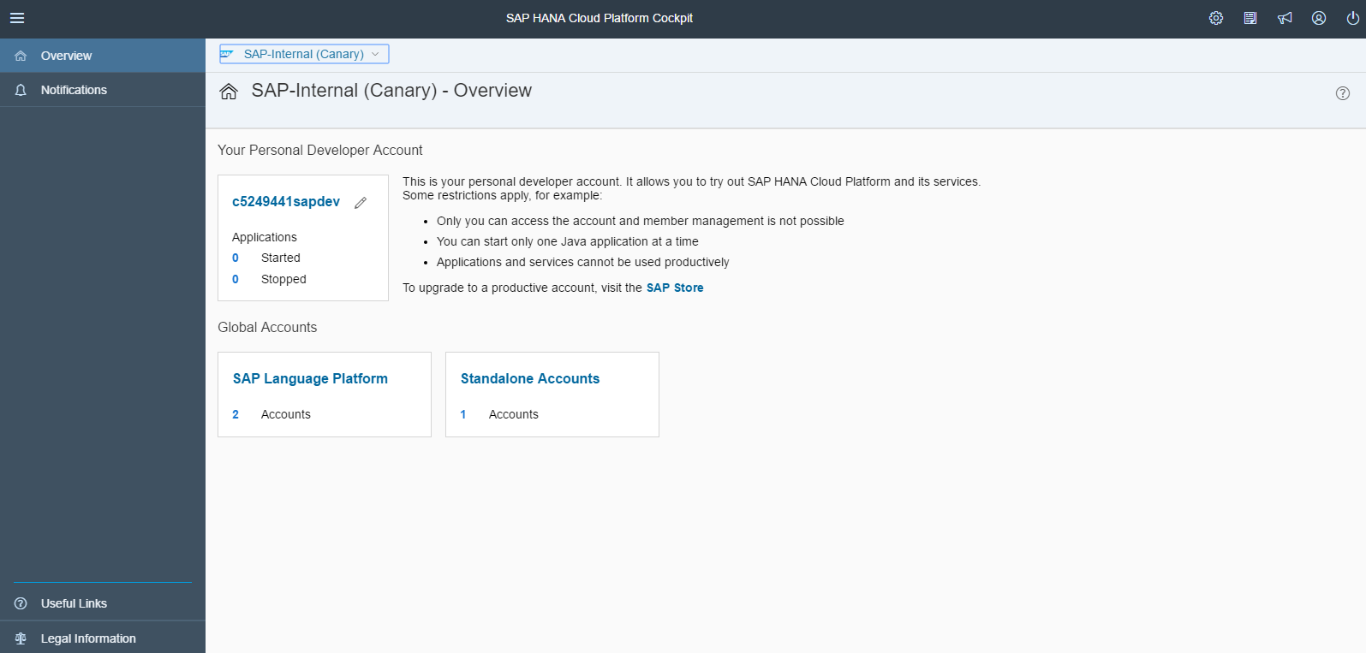

Select “Your Personal Developer Account” (XXXXXXXXsapdev)

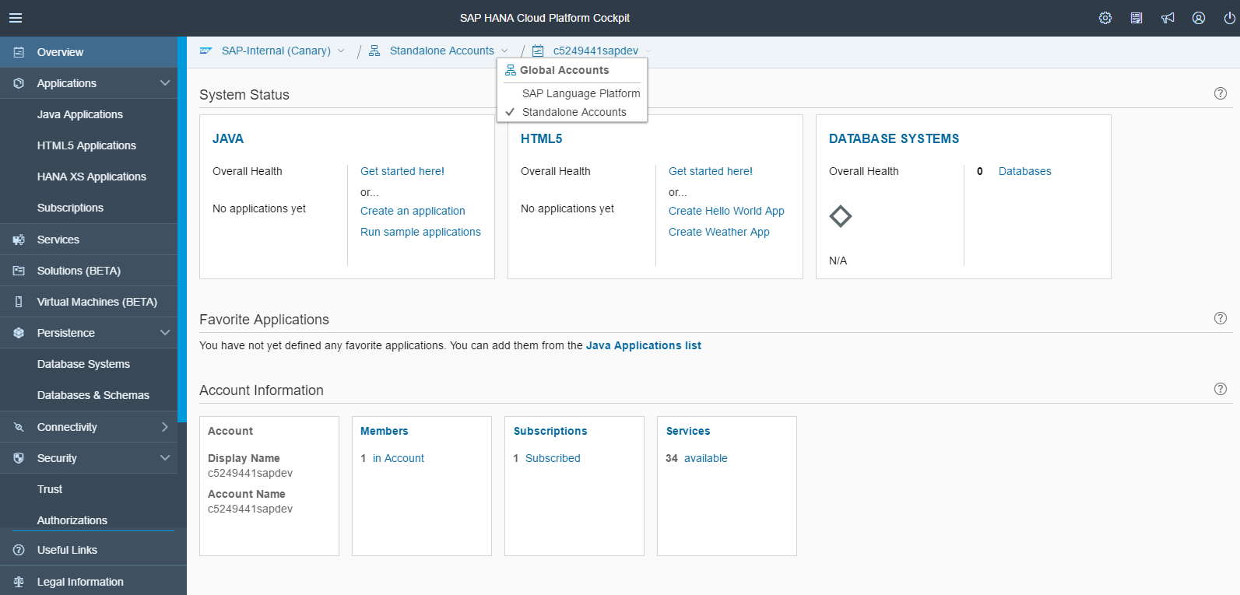

Select “SAP Language platforms” from dropdown

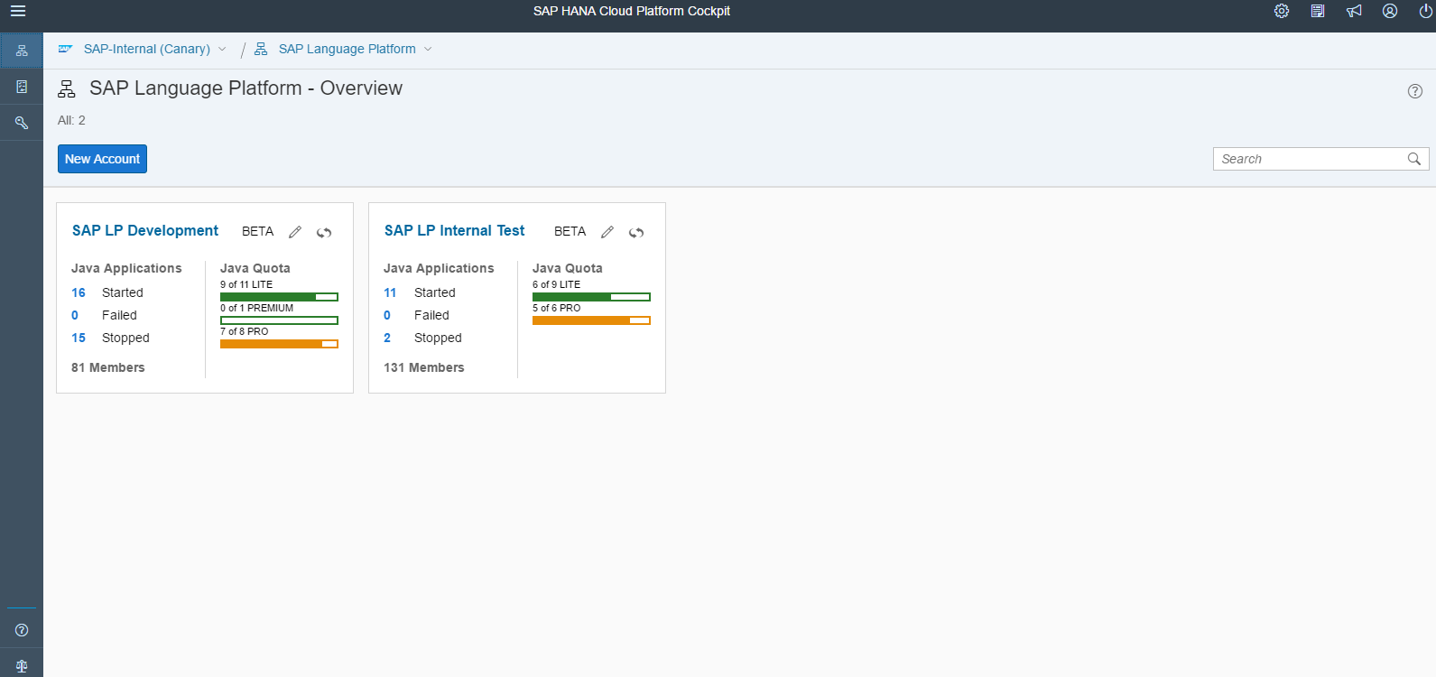

Select development environment SAP LP Development

**Procedure to create HTML Application**

1. Go to ‘HTML5 Applications’ tab. Select New application

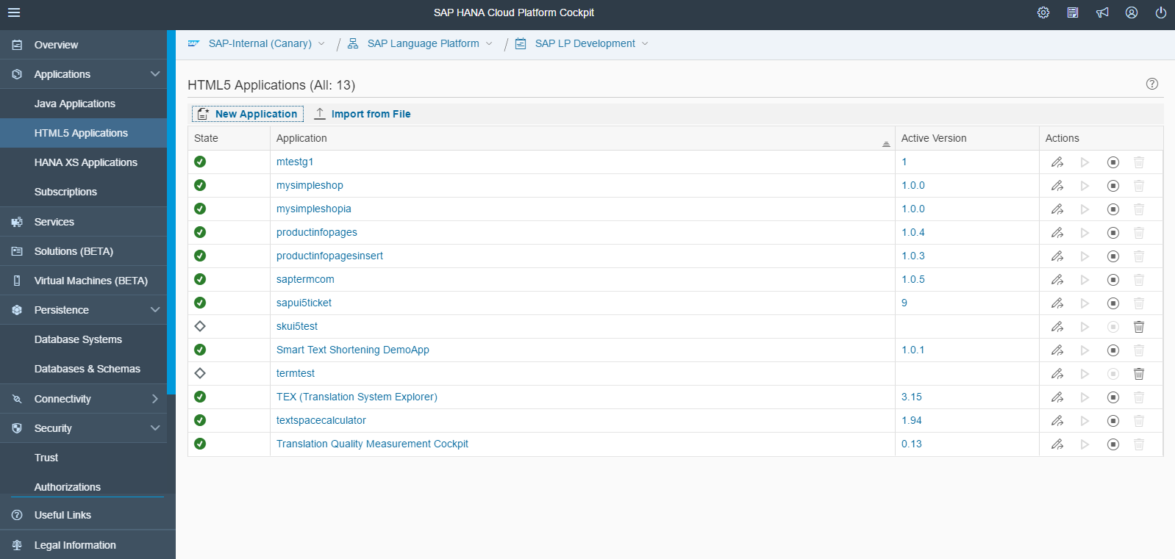

1. Enter the name of application(demokt)

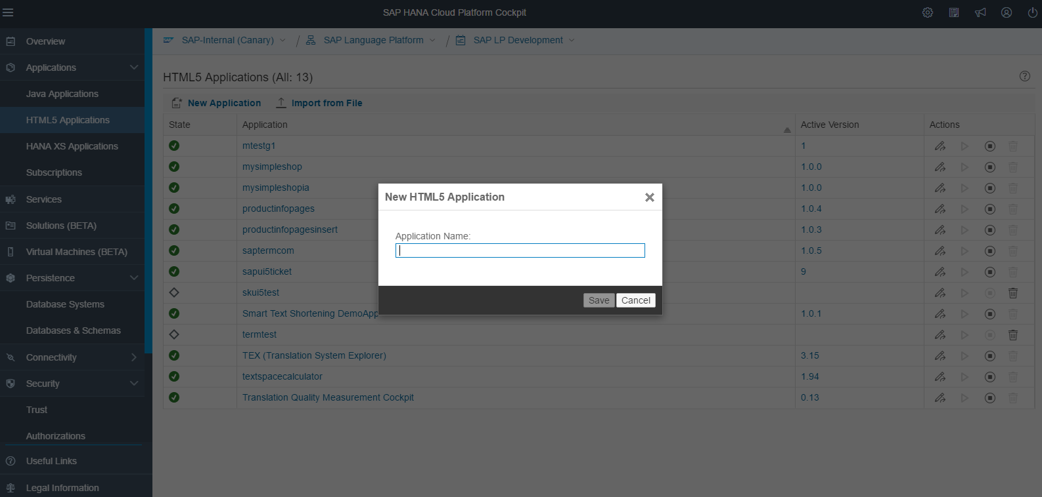

1. Click on Edit option

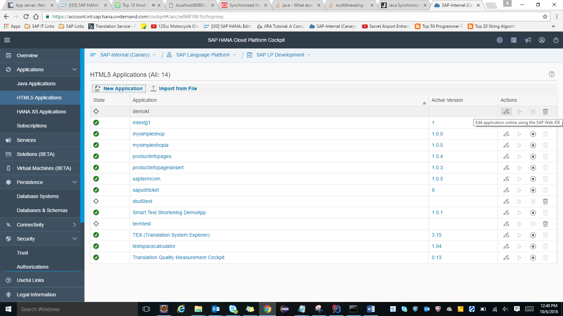

1. Enter username and password

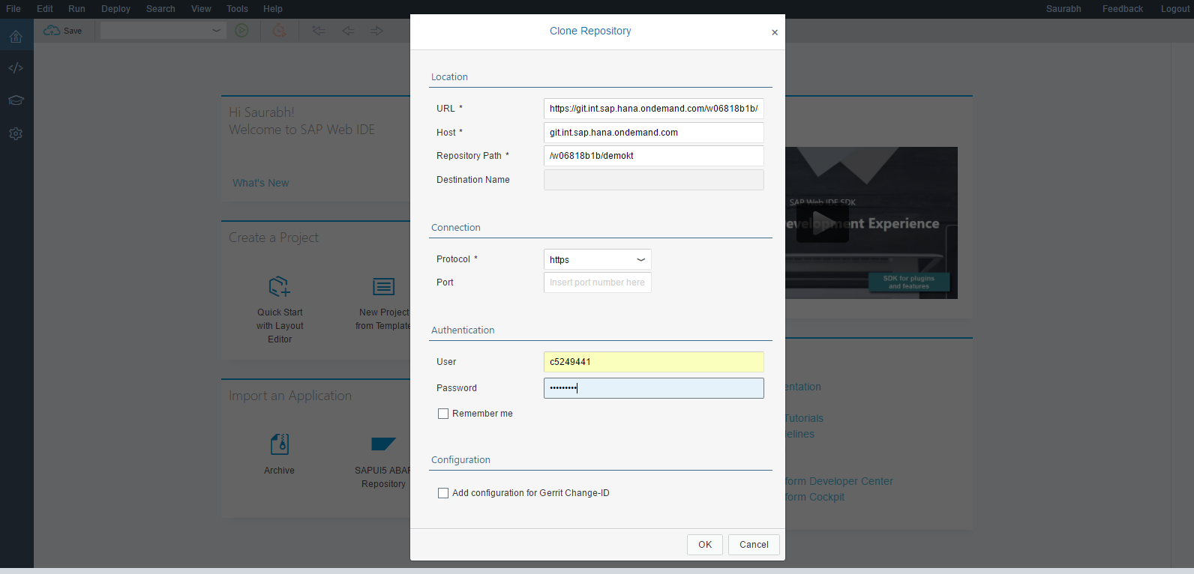

1. Click commit and push

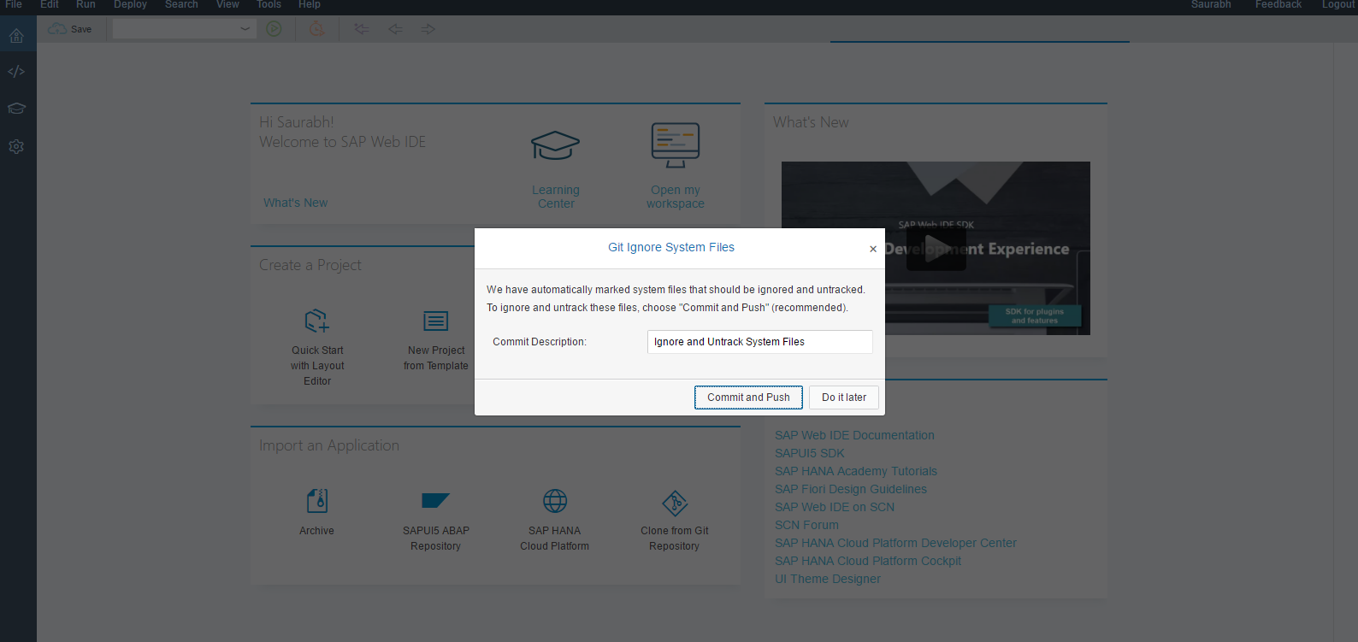

1. Enter your GIT user-ID and Password

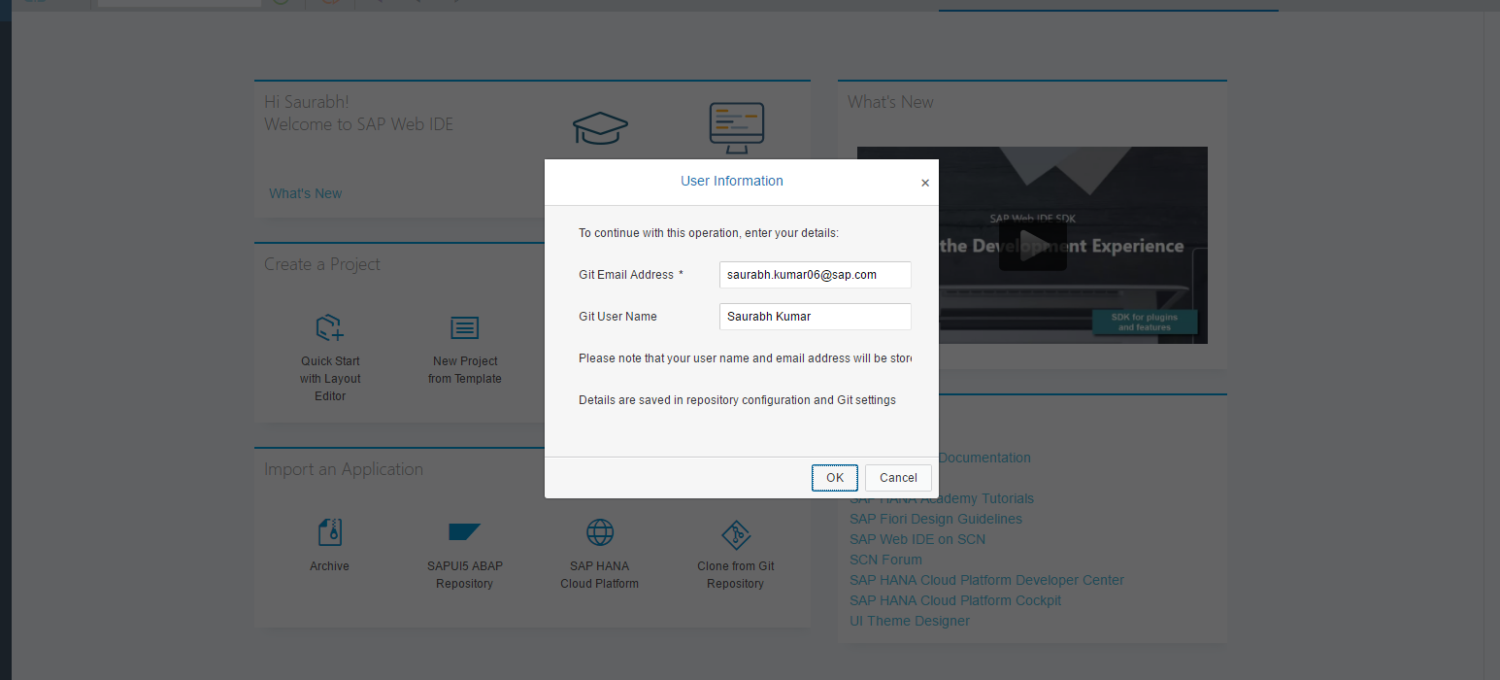

1. Select Code editor Window of Web IDE.

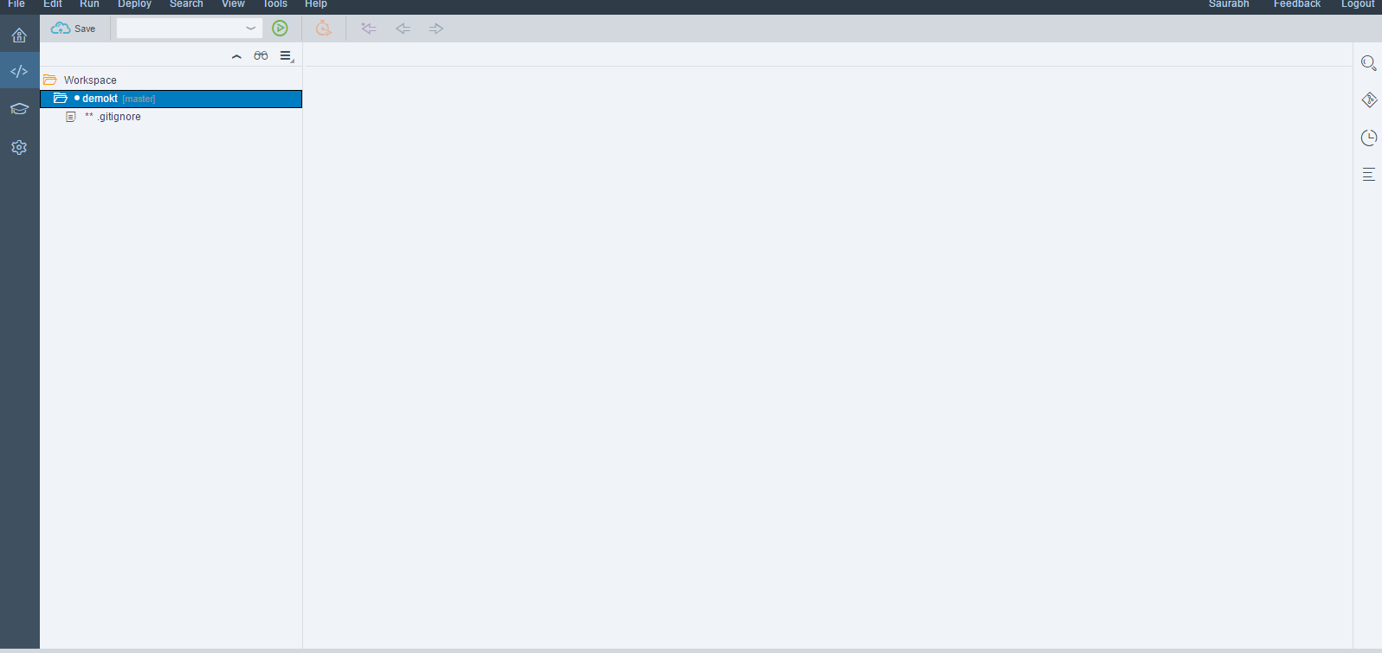

1. Create new file with name i18n.properties and push it in repository.

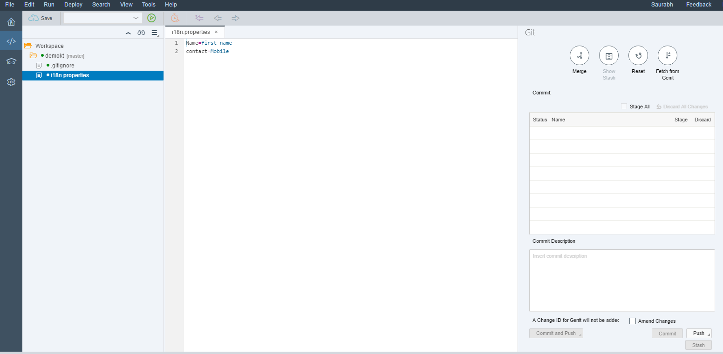

1. Select GIT project and give project name, properties filename and target language. Then click on save

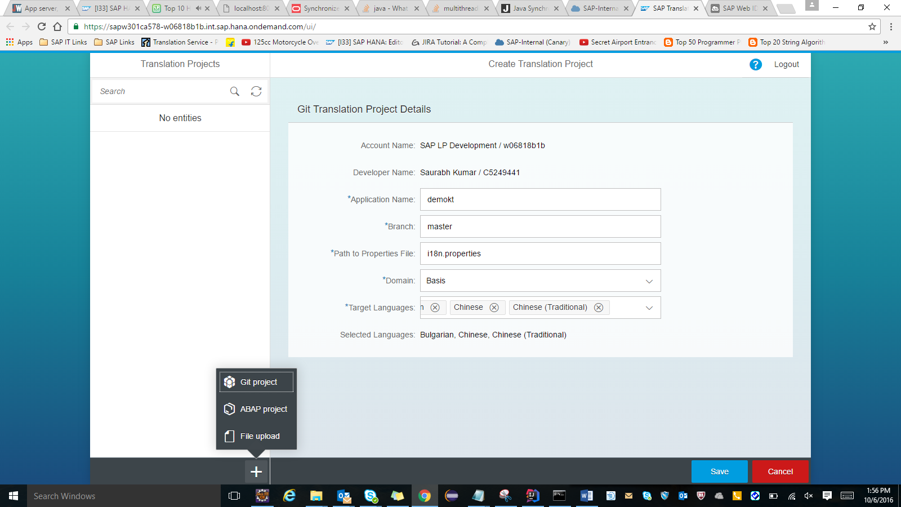

1. Click on Get Translation button and provide your password for translation.

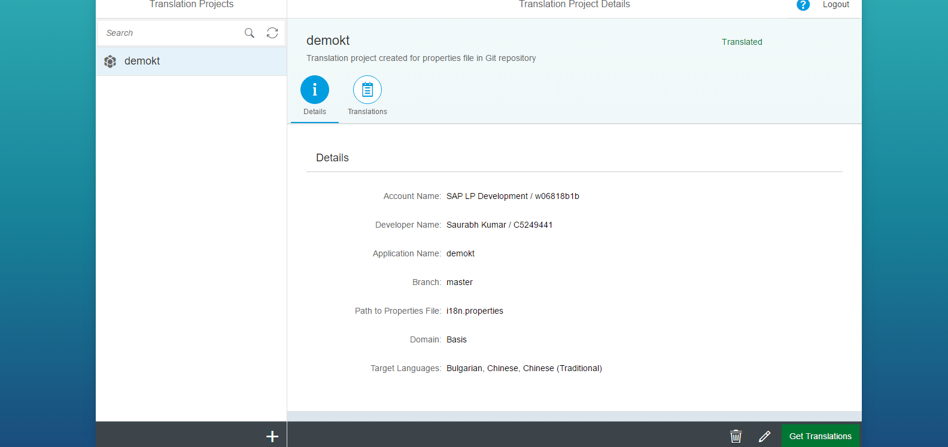

1. To view translation click on translation tab and select language. Translations will be saved to Github repository automatically

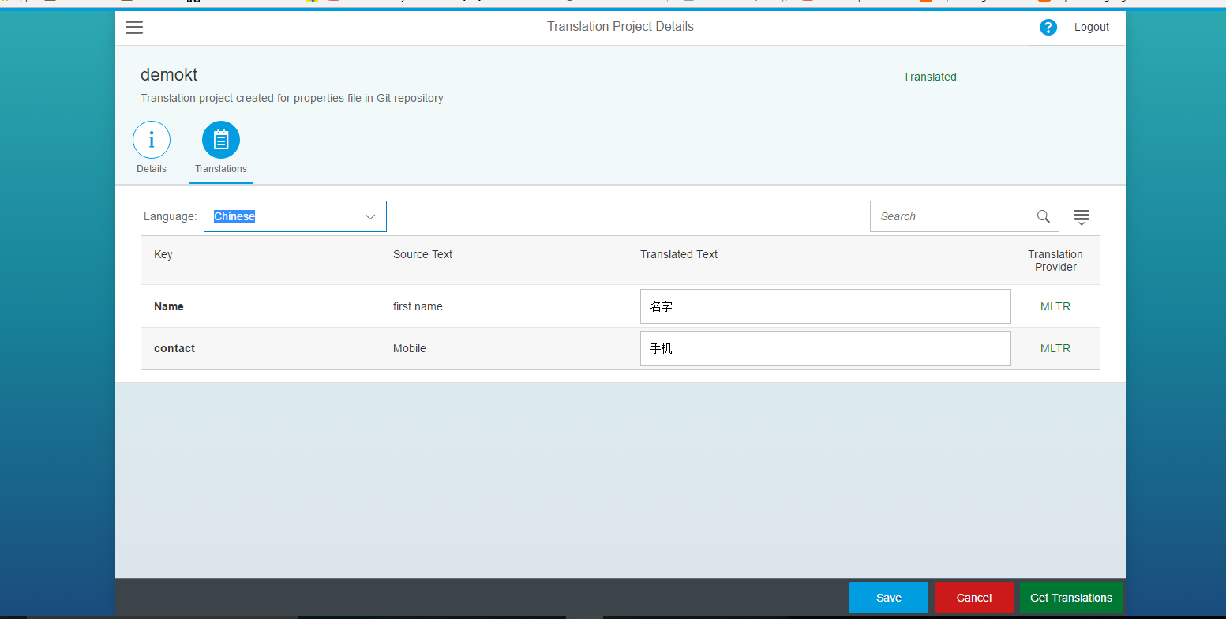

**Translation using ABAP project**

1. Select ABAP project and enter all details and click on save.

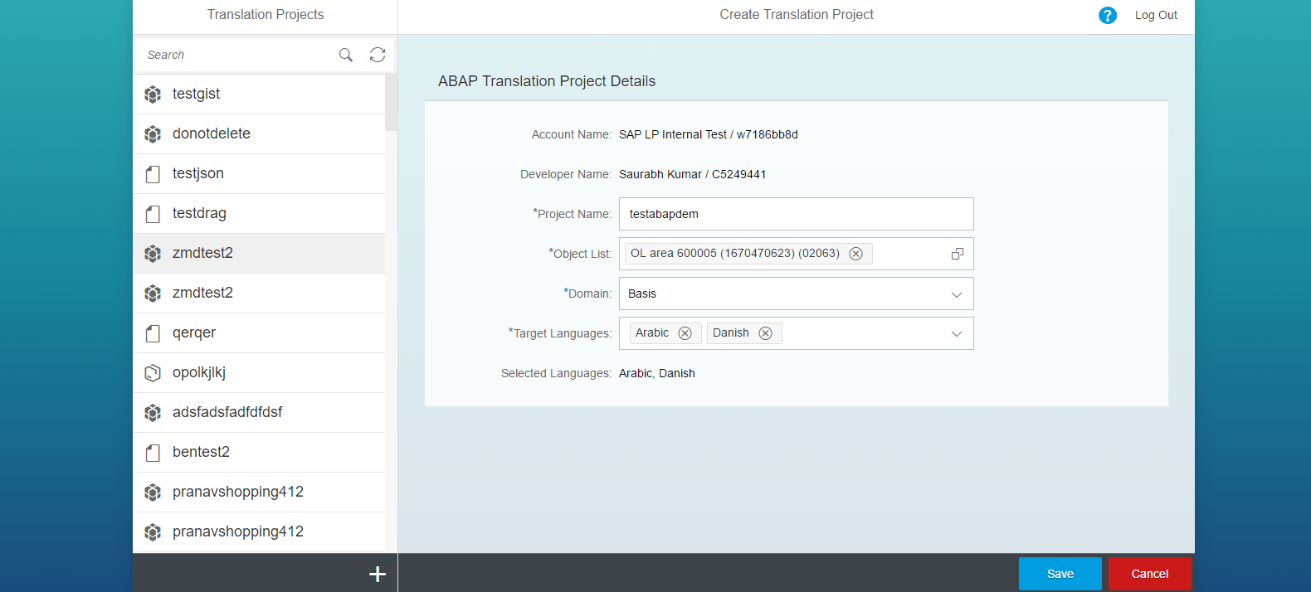

1. Click on get Translation button.

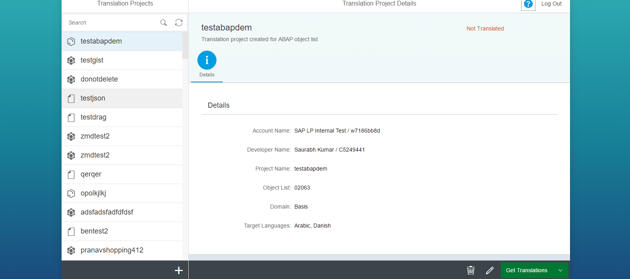

1. Select translation tab to view translation

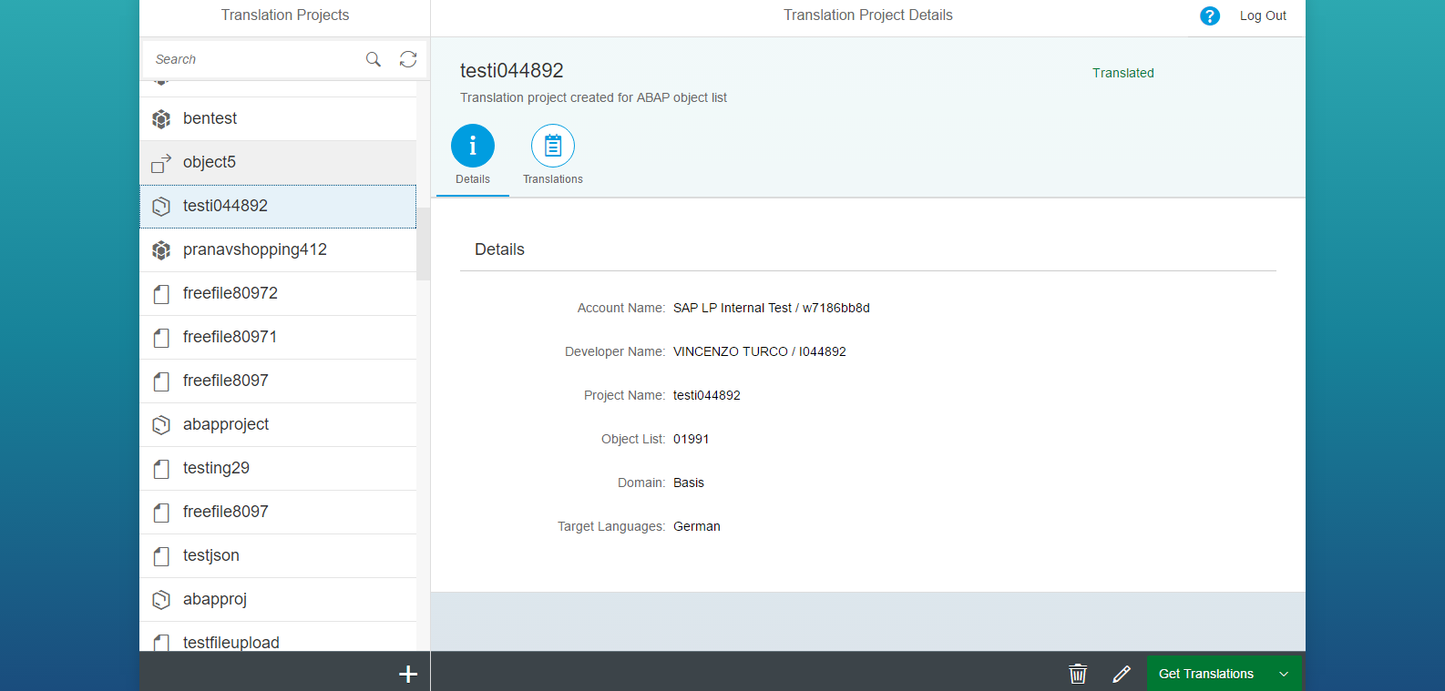

Translation using file upload

1. Select file upload and enter the details and click on save

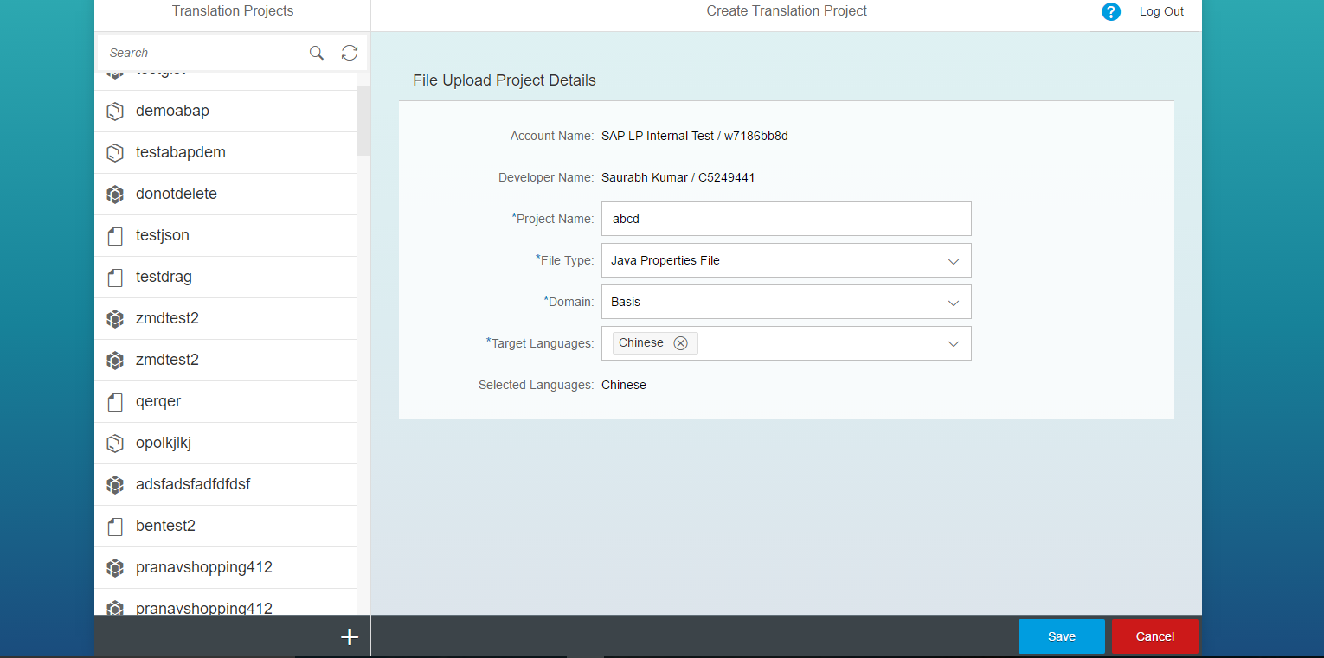

1. Upload files by clicking on upload files option and get the translation.

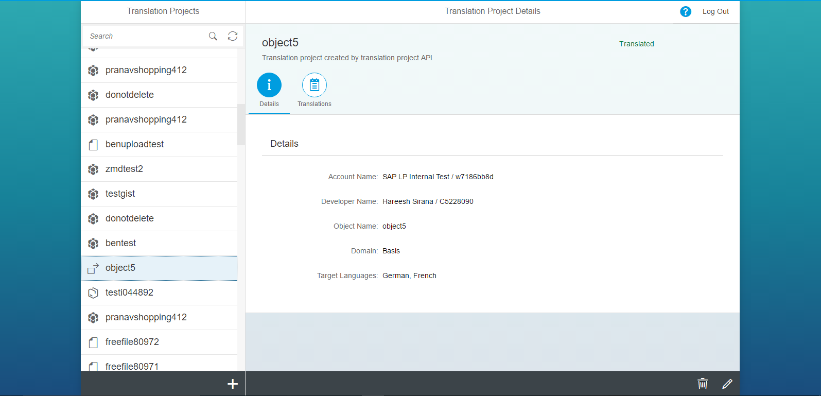

1. Select translation option to view the translation and select language to view translation in specified language.

